Stats & Go – Coach’s Instruction Sheet

Thanks for registering for Stats & Go on StatsAndGo.com. Using Stats & Go to record and publish your entire season statistics is as simple as a few clicks.

Getting Started
Log onto Stats & Go at www.StatsAndGo.com. Add this site to your “favorites” and you won’t have to type it in any more. Next, enter the email address you entered when you registered. Next, enter your password.

You will now arrive at a page that displays your options:

- Step One: Team Settings
- Step Two: Team Roster
- Step Three: Game Schedule/Stats

- Step Four: Media Contacts
- Step Five: The Reporter
- Step Six: My Profile

Always make sure the correct season year is selected here!

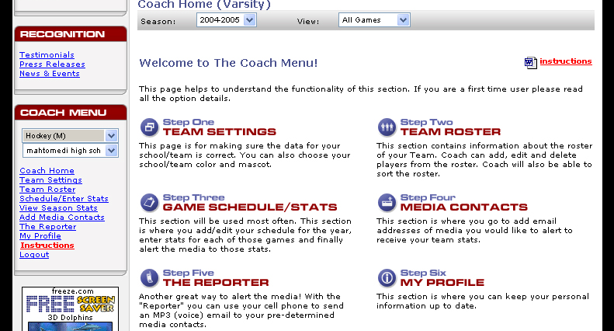
The Coaches Menu lists every option available for coaches. Chances are you will use it often.

These options are redundantly displayed in the main body of the page and in the left hand column. You can click on the entries in the left hand column or on the main page with the same result. Make sure to select the correct season year as shown above!

Step One: Team Settings
The first step is to add or update information related to your team and/or school. You can even set your team colors for your Schools/Teams home page. Simply click on the Color Palate icon select your colors from the chart that pops up.

Click "Save Changes" and program will take you back to the Selection page.

Step Two: Team Roster
Adding your team roster to Stats & Go is easy.

- Click on “Team Roster.”
- Click on "Add New Player."
- Enter players Name, Position, Height (these are the mandatory fields).
- Enter other fields if desired.
- Click "Submit" button and player is entered.
- Repeat above procedure until roster is complete (Complete Roster as best you can before entering Schedule, Adding players later takes extra steps).
- After entering Roster you can use the arrows to rearrange them. You can use this feature to delineate starters.
- Use the "Import Last Year's Roster" feature to import last year’s roster (last year’s seniors are not included and juniors will be promoted to seniors). You need only to add new players or delete those not playing.
- When your Roster is entered you need to click Schedule/Enter Stats in the left column.

Step Three: Game Schedule/Stats
Set Schedule & Enter Stats (Page says "Team Games")

To Enter a High School Schedule, follow these simple steps:
  - Click on "Add a New Game"
  - Scroll to find the State your Opponent is from.
  - Be sure second box says "High School."
  - Scroll to find Opponent (If you can't find opponent either contact us or enter it yourself).
  - Select Varsity, JV, 10th grade or 9th grade as appropriate.
  - Click on calendar to pick game date. Use arrows to find month. Click on date.
  - Select Home or Away. If Neutral site you type in site after program refreshes.
  - Make sure Green Dots are in correct boxes that apply to that game.
  - Click yes to: Will Play Again. This lets you enter two games with one opponent.
  - Click "Submit" and repeat procedure until schedule is complete.

Following a game simply enter your stats:
- Click on Schedule/Enter Stats.
- Click on the clipboard at the right of the game you wish to enter (Baseball, Softball, Volleyball, Soccer and Football have dual clipboards - blue to enter your stats, red to enter opponent stats).

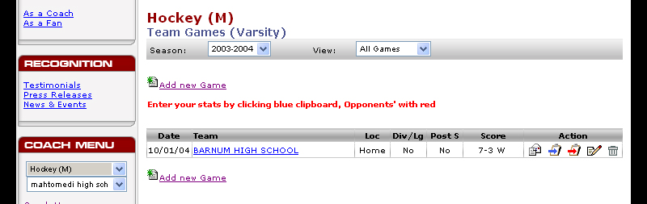
Click on a clipboard! Blue to enter your team’s stats, red for your those of your opponent.

- Enter your stats. There is no need to enter zeros. Stats & Go will take care of the zeros.
- If you choose, enter game notes. The first notes box are for notes you wish not to send to the media. Enter notes for members of the media in the second box. Some coaches send their newspaper articles this way.
- In Basketball, Soccer, and Volleyball coaches can track a stat of their own by choosing the (oth) category.

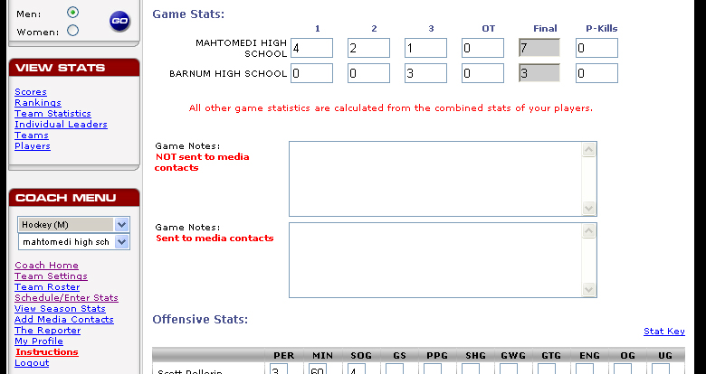
Game notes entered in the top box remain private. Notes in the lower box are sent to the media.
Use this link for a key of stats abbreviations.

- After entering your stats, click "Save Only" if you just want to save the stats. Stats & Go will simply save and compile them. Or click "Save and Email Stats to the Media" to save the stats, compile and send a report to the email addresses of your media contacts.
- That’s it! If you need to change stats later you go to the page, enter the changes and Save.

Step Four: Media Contacts
Enter your media contacts. Stats & Go will save you the hassle of faxing copies of your stats to other statisticians and the media. Just enter the e-mail addresses of those who would like a report, and Stats & Go will provide the report automatically with just one click. Here’s how:

- Click “Add New Contact.”
- Enter their information in the form provided.
- Click “Submit.” That’s it! Repeat these steps for each contact.

Step Five: The Reporter - Optional
Notify all of your contacts with one phone call. The Reporter feature makes it possible. Here’s how it works:
- Click on “The Reporter”
- If you have already registered for The Reporter, call the number on the page that opened (415) 382-4220.
- If you need to establish an account, simply click on The Reporter logo and follow the directions online.

Step Six: My Profile
If you need to update information regarding your personal contact information, this is the place. Simply make your changes and click save.

