Stats & Go – Fan’s Instruction Sheet

Thanks for using StatsAndGo.com to keep track or all your favorite amateur teams and athletes. Here are some simple instructions for making sure you never miss a stat.

Getting Started
Log onto Stats & Go at www.StatsAndGo.com. Add this site to your “favorites” and you won’t have to type it in any more.

- From the selection of sports across the top click on the sport in which you are interested. For example, clicking on “Basketball” takes you to basketball stats as shown below.

- Stats & Go archives stats from prior years. You can access these by changing the season year in the “Season” box. In the "Search" box beneath it, you can choose to view stats for either men’s or women’s teams. Choose one, and click “Go.”

View State or National Team Rankings

The first time you visit Stats & Go, you will arrive at the "National" team rankings page. The “Search” will reflect this. To access team rankings (team leaderboard) for a given state, click on the arrow next to the word “NATIONAL.” Simply select the state from the drop down menu, and click go. NOTE: Following your visit, Stats & Go will train your computer to remember the state you visited last.

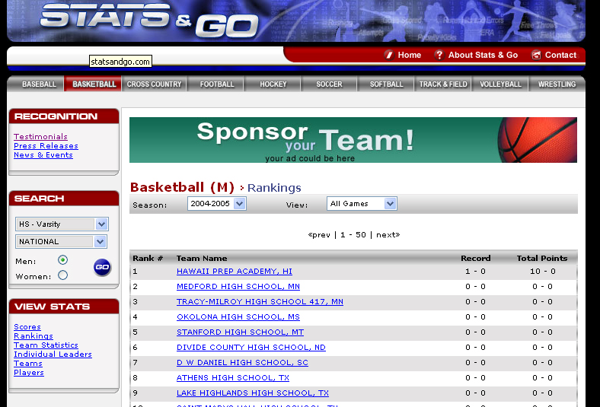
Stats & Go archives stats from prior years. Access them here.
Here you can access national stats or those for a specific state, and for either men’s or women’s teams.
To view comprehensives team and player stats, simply click on the team name.

Keep in mind that the only teams that show up are the ones that have coaches or statisticians using the program as their stats program.

View Team and Individual Player Stats
For each team on the leaderboard, Stats & Go also compiles comprehensive team and player information. Simply click on the team name to access the team’s schedule, roster, record, and last game results.

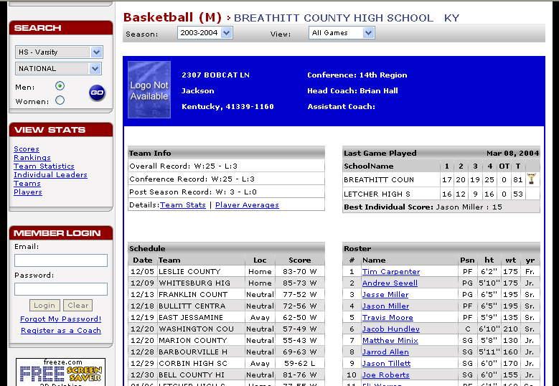
Team Info shows the team’s record, and provides access to Team Stats and Player Averages.
Clicking on a player’s name on the roster provides access to that player’s comprehensive stats.

Using the View Stats Box
The View Stats box contains navigation links designed to simply and quickly allow you access to a wide variety of information.

- Scores will provide you with latest game results for the sport (shown below).

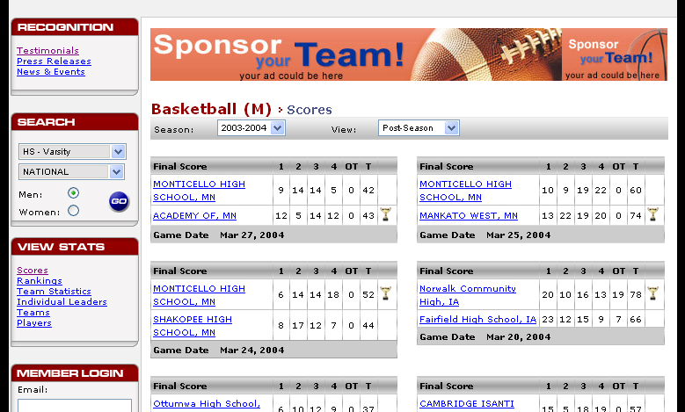
The View Stats box provides simple navigation and quick access to detailed information.

- Rankings gives you immediate access to the Team Leaderboard.

- Team Statistics provides comprehensive statistics for each team on the Team Leaderboard.

- Individual Leaders provides the ability to determine leaders in any given statistic. Simply click on the category to sort the list by that category (ex. PPG, FG%, etc.).

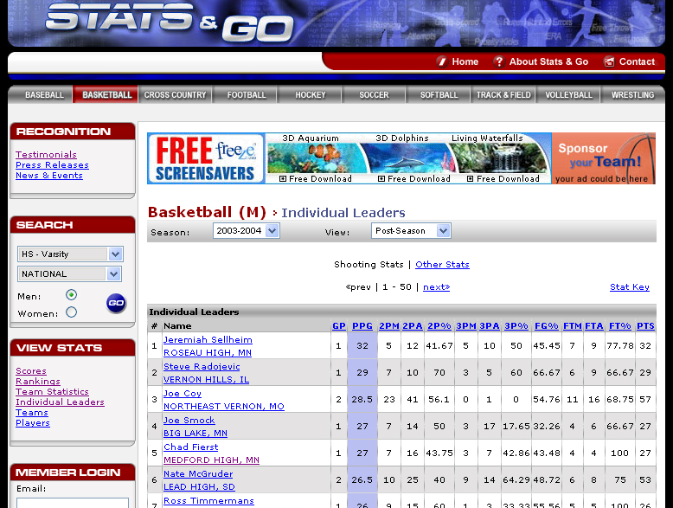
On the “Individual Leaders” page, you can sort the list by any statistical category you choose.
The “Stats Key” gives you definitions of the abbreviations used by Stats & Go.
Access individual and team stats here.

From this page, access a player’s individual stats by clicking on his/her name. Access that player’s team stats by clicking on the team name.

By changing your selection in View, you can access stats pertaining only to conference games. Follow the same steps to view conference leaders along with team and individual stats in a given conference.

When viewing stats for a given state, you can view leaders by conference by selecting a conference from the dropdown menu.

- Teams allows you to quickly access stats for a certain team. If you do not know the correct spelling a certain team, click on the first letter of the teams name to see a list of all teams beginning with that letter.

- Players allows you to quickly access stats for a certain player. If you do not know the correct spelling of that player’s name, select his or her position and the first letter of their last name.

